
FACULTY OF ENGINEERING AND TECHNOLOGY

Course Code: CEF 440
Course Title: Internet Programming (J2EE) and Mobile Programming
Course Instructor: Dr.Nkemeni Valery
SN | NAMES | MATRICULE
1 | NKONGHO ELIZABETH AGBOR-MANYO | FE23A122
2 | TANDO CALVIN NKUH | FE23A159
3 | DIVINE JEMBONG TABI NDIP | FE23A035
4 | LENA KEZIAH ABANDA GHA | FE23A081
5 | MENYE EWODO GERMAINE LAETICIA | FE23A092

Task 6: Database Design and Implementation

Table of Contents
- 1. Introduction
- 2. Data Elements & Data Dictionary
  - User
  - Course
  - Course Content
  - User Progress
  - Offline Downloads
  - Quiz
  - Quiz Attempt
  - Assignment
  - Notification
  - Network Monitoring
  - Adaptive Content Delivery
- 3. Conceptual Relationship of Data Elements
- 4. Conceptual Database Design (Textual Database Model)
  - 4.1.1 Entities and Data Dictionary
    - USER Entity
    - COURSE Entity
    - LESSON Entity
    - MESSAGE Entity
    - NETWORK_LOG Entity
    - ENROLLMENT Entity (Associative Entity)
  - 4.1.2 Relationships and Cardinalities
  - 4.1.3 Business Rules
- 5. Entity-Relationship
  - 5.1 Introduction
  - 5.2 Structural Breakdown of Entities and Data Dictionary
    - 5.2.1 USER Entity
    - 5.2.2 COURSE Entity
    - 5.2.3 LESSON Entity
    - 5.2.4 ENROLLMENT Entity
    - 5.2.5 MESSAGE Entity
    - 5.2.6 NETWORK_LOG Entity
- 6. Relationships, Cardinality Rules, and Enforcement
  - 6.1 Course Authorship Constraint
  - 6.2 Lesson Structural Dependency
  - 6.3 Many-to-Many Enrollment Bridge
  - 6.4 Bidirectional Communication Routing
  - 6.5 High-Frequency Telemetry Tracking
- 7. Platform Adaptation Business Rules

8.Backend Implementation
- 8.1 Introduction
- 8.2 Database Design
  - 8.2.1 Why MongoDB
  - 8.2.2 Mongoose and Schema Design
  - 8.2.3 Indexing Strategy
- 8.3 API Design and Routing
  - 8.3.1 REST Architecture
  - 8.3.2 Request and Response Format
- 8.4 Authentication and Security
  - 8.4.1 JWT Authentication
  - 8.4.2 Role-Based Access Control
  - 8.4.3 Environment Configuration and Security
- 8.5 The Adaptive Learning Engine
- 8.6 Server Setup and Deployment
- 8.7 Summary

1. Introduction

This report documents the technical architecture of Adaptis, an adaptive e-learning platform built specifically for low-bandwidth and offline environments. It outlines the core Data Elements required to track users, courses, offline downloads, and network diagnostics across the application. It then details the Conceptual Design and Entity-Relationship (ER) Diagram, mapping out the structural tables, cardinality rules, and database constraints like course authorship and lesson dependencies. Finally, the report covers the Backend Implementation, explaining how the Node.js, Express.js, and MongoDB Atlas ecosystem packages multi-tier media fallbacks together, allowing the mobile application to switch formats instantly when connection quality changes.
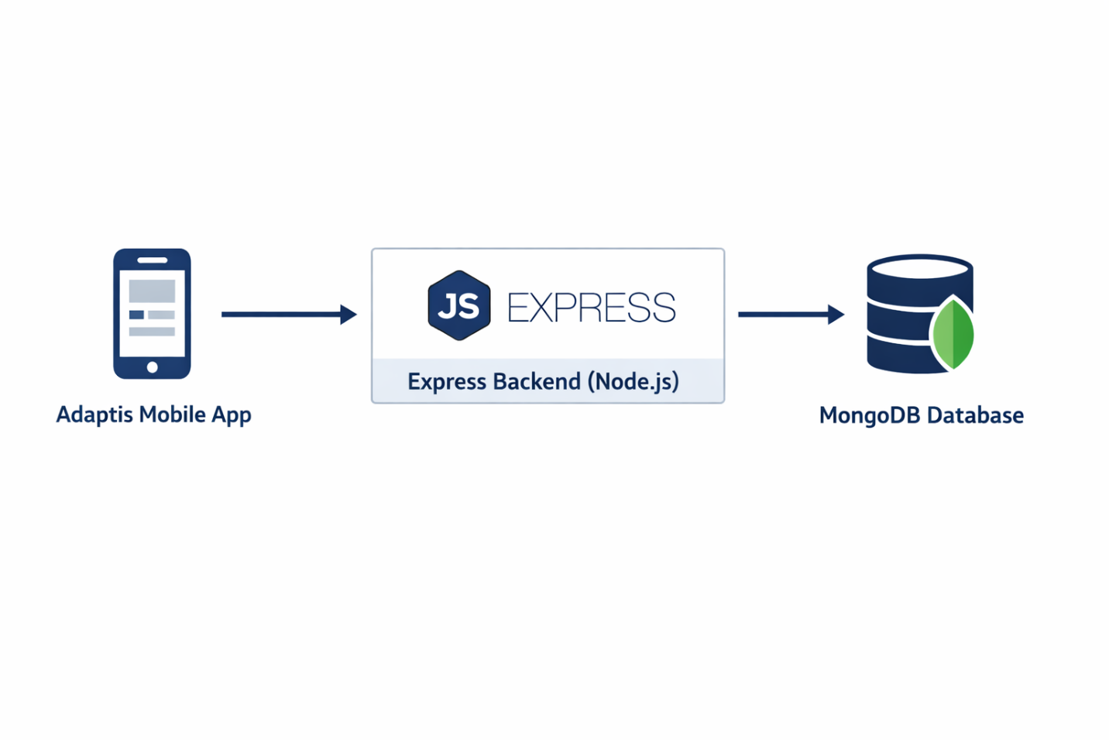

2. Data Elements
- User
- User ID – unique identifier for each user.
- Full Name – name of the student, teacher, or administrator.
- Email Address – used for registration and login.
- Password Hash – encrypted password for security.
- Role – Student, Teacher, or Administrator.
- Account Status – active, inactive, or suspended.
- Date Created – when the account was created.
- Course
- Course ID – unique identifier for each course.
- Course Title – name of the course.
- Course Description – summary of course content.
- Teacher ID – instructor responsible for the course.
- Course Category – subject area or discipline.
- Creation Date – date the course was added.

Course Content
- Content ID – unique identifier for learning material.
- Course ID – links content to a course.
- Content Title – title of the lesson or material.
- Content Type – video, audio, PDF, or text.
- Content URL/File Path – location of stored content.
- Content Size – storage size of the material.
- Upload Date – date content was uploaded.

User Progress
- Progress ID – unique identifier for progress records.
- User ID – student associated with the progress.
- Course ID – course being tracked.
- Completion Percentage – percentage completed.
- Current Module – last accessed module.
- Last Access Date – most recent activity.

Offline Downloads
- Download ID – unique identifier.
- User ID – owner of the download.
- Content ID – downloaded learning material.
- Download Status – pending, completed, or failed.
- Download Date – date of download.

Quiz
- Quiz ID – unique identifier.
- Course ID – course linked to the quiz.
- Quiz Title – name of the assessment.
- Total Marks – maximum obtainable score.
- Creation Date – date quiz was created.

Quiz Attempt
- Attempt ID – unique identifier.
- Quiz ID – associated quiz.
- User ID – student taking the quiz.
- Score – marks obtained.
- Submission Date – date submitted.
- Attempt Status – completed or pending sync.

Assignment
- Assignment ID – unique identifier.
- Course ID – associated course.
- Student ID – submitting student.
- Submission File – uploaded assignment.
- Submission Date – date submitted.
- Grade – score awarded.

Notification
- Notification ID – unique identifier.
- User ID – recipient.
- Notification Type – message, deadline, or update.
- Notification Content – message text.
- Delivery Status – sent, queued, or delivered.

Network Monitoring
- Network Record ID – unique identifier.
- Connection Type – WiFi or Mobile Data.
- Connection Quality – Good, Fair, or Poor.
- Measured Speed – internet speed result.
- Timestamp – time of measurement.

Adaptive Content Delivery
- Delivery ID – unique identifier.
- Content ID – content being delivered.
- Selected Mode – HD Video, SD Video, Audio, or Text.
- Switch Time – time content mode changed.
- Reason for Switch – network condition.

3. Conceptual Relationship of Data Elements
A user can enroll in one or more courses. Each course contains multiple learning materials, quizzes, and assignments. Students generate progress records, quiz attempts, downloads, and notifications. Adaptive content delivery records and network monitoring data help the system adjust learning content based on internet quality.
4. Conceptual Database Design (Textual Database Model)
The conceptual database design defines the structure of the system in terms of entities, attributes, relationships, and business rules. This model serves as the foundation for the physical database implementation and ER diagram creation.
4.1.1 Entities and Data Dictionary
- USER Entity
Represents all users of the system including students, teachers, and administrators.
- Attributes:
- User_ID (Primary Key)
- Full_Name
- Email (Unique)
- Password_Hash
- Role (Student, Teacher, Admin)
- Location
- Device_Type
- Created_At
- COURSE Entity
Represents learning programs created on the platform.
- Attributes:
- Course_ID (Primary Key)
- Course_Title
- Course_Description
- Category
- Difficulty_Level
- Created_By (Foreign Key → USER)
- Created_At

- LESSON Entity
Represents learning content within a course with adaptive media support.
- Attributes:
- Lesson_ID (Primary Key)
- Course_ID (Foreign Key → COURSE)
- Lesson_Title
- Lesson_Content_Text
- Video_URL_HD
- Video_URL_SD
- Audio_Text_URL
- Lesson_Order
- Duration_Minutes
- MESSAGE Entity
Represents communication between users in the system.
- Attributes:
- Message_ID (Primary Key)
- Sender_ID (Foreign Key → USER)
- Receiver_ID (Foreign Key → USER)
- Message_Content
- Timestamp
- Sync_Status (Pending Sync / Synced)
- Message_Type
- NETWORK_LOG Entity
Stores network performance and user experience data.
- Attributes:
- Log_ID (Primary Key)
- User_ID (Foreign Key → USER)
- Network_Condition (Good / Fair / Poor)
- QoE_Score
- Latency_ms
- Timestamp
- ENROLLMENT Entity (Associative Entity)
Resolves the Many-to-Many relationship between USER and COURSE.
- Attributes:
- Enrollment_ID (Primary Key)
- User_ID (Foreign Key → USER)
- Course_ID (Foreign Key → COURSE)
- Enrollment_Date
- Progress_Percentage
- Status (Active / Completed / Dropped)
4.1.2 Relationships and Cardinalities
- A USER can enroll in multiple COURSES, and a COURSE can have multiple USERS (Many-to-Many via ENROLLMENT).
- A USER (Teacher) can create multiple COURSES, but each COURSE is created by one USER.
- A COURSE contains multiple LESSONS, but each LESSON belongs to one COURSE (One-to-Many).
- A USER can send multiple MESSAGES, but each MESSAGE has one sender (One-to-Many).
- A USER can generate multiple NETWORK_LOG records over time (One-to-Many).
4.1.3 Business Rules
- Each USER must have exactly one role: Student, Teacher, or Admin.
- Each COURSE must be created by one USER with the role Teacher.
- A USER can enroll in multiple COURSES, and a COURSE can have multiple USERS.
- Each LESSON must belong to exactly one COURSE.
- Lessons must follow a defined sequential order within each course.
- Each MESSAGE must have one sender, one receiver, and a timestamp.
- Messages marked as “Pending Sync” must synchronize when network is restored.
- Each USER must generate multiple NETWORK_LOG entries for QoE tracking.
- Each LESSON must support at least one adaptive content format (HD, SD, or Audio/Text).
- Referential integrity must be maintained across all entities.
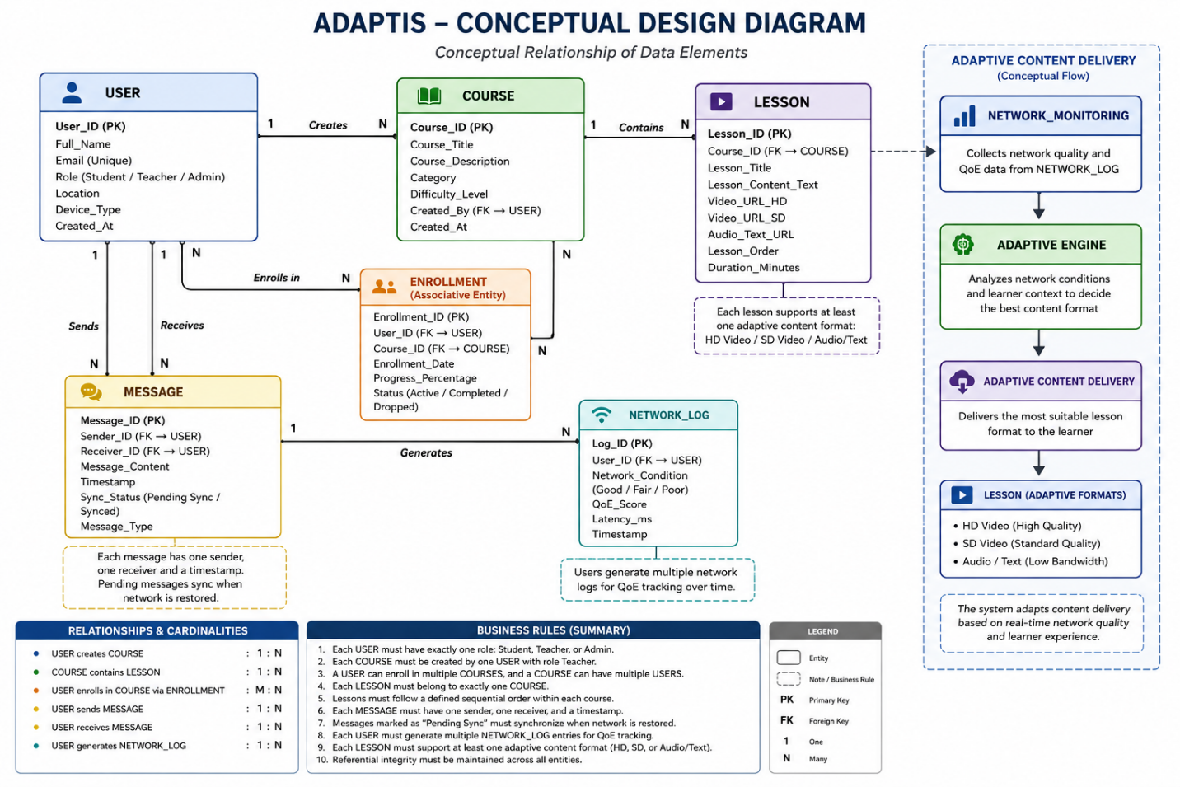

5. ENTITY-RELATIONSHIP

5.1 Introduction
This section provides a straightforward explanation of the database design for the Adaptive E-Learning Platform. The database is designed to store and link information so that the platform runs smoothly, even when a user has a very slow or unstable internet connection. It automatically tracks user profiles, lessons, messaging, and real-time internet performance data.

5.2 Structural Breakdown of Entities and Data Dictionary
The database organizes information into six main folders, called tables. Each table holds a specific type of data.

5.2.1 USER Entity
This table stores basic profile information for everyone who logs into the platform, including students, teachers, and system administrators.
- User_ID: A unique identification number automatically given to each person.
- Full_Name: The first and last name of the user.
- Email: The user's registered email address, which cannot be shared by any two accounts.
- Password_Hash: A scrambled, secure version of the user's password.
- Role: The type of user account, which must be exactly "Student", "Teacher", or "Admin".
- Location: Where the user is connecting from geographically.
- Device_Type: The hardware being used, such as a mobile phone, tablet, or laptop.
- Created_At: The exact date and time the user account was first created.

5.2.2 COURSE Entity
This table lists the master catalog of all classes or learning tracks hosted on the platform.
- Course_ID: A unique identification number for each individual course.
- Course_Title: The name of the class.
- Course_Description: A summary of what the class covers.
- Category: The academic topic or subject group.
- Difficulty_Level: How advanced the class is, such as beginner or expert.
- Created_By: The identification number of the specific teacher who built the course.
- Created_At: The date and time the course was published.

5.2.3 LESSON Entity
This table contains the individual pages or learning modules found inside a course. It is built to support multiple file options so content still loads when internet connection drops.
- Lesson_ID: A unique identification number for the lesson.
- Course_ID: A connecting tag that identifies which course this lesson lives inside.
- Lesson_Title: The name of the lesson.
- Lesson_Content_Text: The main reading material and text transcripts.
- Video_URL_HD: A link to a high-definition version of the lecture video.
- Video_URL_SD: A link to a lower-quality video that loads faster on weak connections.
- Audio_Text_URL: An ultra-lightweight audio version or a text-only summary that can download even when internet speeds are extremely poor.
- Lesson_Order: The exact numerical sequence of the lesson, ensuring students take topics in order.
- Duration_Minutes: An estimate of how long it takes to complete the lesson.

5.2.4 ENROLLMENT Entity
This table keeps track of whenever a student registers for a class. It acts as a bridge showing exactly who is taking what course and how far along they are.
- Enrollment_ID: A unique confirmation number for the course registration.
- User_ID: The identification number of the student who is participating.
- Course_ID: The identification number of the class they are taking.
- Enrollment_Date: The calendar date the student signed up.
- Progress_Percentage: A live counter from 0 to 100 tracking how much content the student has completed.
- Status: The current state of the registration, which must be "Active", "Completed", or "Dropped".

5.2.5 MESSAGE Entity
This table logs all conversations and chat updates sent between users on the platform.
- Message_ID: A unique tracking number for each text message.
- Sender_ID: The identification number of the user who typed and sent the message.
- Receiver_ID: The identification number of the user intended to read the message.
- Message_Content: The actual text written by the user.
- Timestamp: The exact clock time the message was created.
- Sync_Status: A tracking label marked as either "Synced" or "Pending Sync". If a user tries to send a text while completely offline, it stays as "Pending Sync" on their phone and uploads to the server later when connection returns.
- Message_Type: A category marker to handle internal system alerts or direct user-to-user chats.

5.2.6 NETWORK_LOG Entity
This table works silently in the background, continuously saving performance data from the user's internet connection to help the system adjust video quality automatically.
- Log_ID: A unique identification number for the connection check.
- User_ID: The identification number of the person whose device is being tested.
- Network_Condition: A simple connection rating labeled as "Good", "Fair", or "Poor".
- QoE_Score: A score indicating the user's overall technical experience based on how fast features are loading.
- Latency_ms: The exact internet transmission lag measured in milliseconds.
- Timestamp: The exact historical time this specific internet speed snapshot was taken.

6. Relationships, Cardinality Rules, and Enforcement
The database uses precise linking rules to make sure data is shared accurately and safely between tables without losing track of important files.

6.1 Course Authorship Constraint
The database links the user list straight to the course list. A teacher can create as many different classes as they want, but every individual course must list exactly one teacher as its author. The system blocks courses from being built by regular students or administrators.

6.2 Lesson Structural Dependency
Lessons are strictly locked inside their parent courses. A lesson cannot exist by itself in the open system. If a teacher deletes an entire course from the platform, the database automatically cleans up and deletes every single lesson attached to that course so that no broken files are left taking up server space.

6.3 Many-to-Many Enrollment Bridge
A student can join multiple different classes, and a single class can contain hundreds of enrolled students. Instead of creating a complicated mess of crossed data lines, the enrollment table sits right between the user and course tables to handle this matching smoothly. This keeps a student's grades and progress percentage in one class completely separate from their performance in another.

6.4 Bidirectional Communication Routing
When a message is sent, the database draws two separate links back to the user profiles. One link tags the sender and the other tags the recipient. This allows the database to instantly build a two-way chat history for any user without needing to build separate tables for sent mail and received mail.

6.5 High-Frequency Telemetry Tracking
Each individual user profile builds up a continuous history of connection speed updates over time inside the network logs. This data links back directly to the account that generated the background traffic.

7. Platform Adaptation Business Rules
The relational data schema explicitly enforces concrete core business requirements outlined in the functional design parameters:
- Role Constraint Enforcement: Checking logic prevents users from accessing features outside their assigned role (Student, Teacher, Admin).
- Instructor Validation: Data verification ensures that the field tracking course creation maps only to a user account with a validated "Teacher" role string.
- Content Adaptation Architecture: As a student works through a lesson, the platform reads the connection ratings stored inside the network log table. If the log shows a connection score of "Poor", the system blocks the heavy high-definition video link and automatically serves the standard-definition video or the audio fallback text file instead. This keeps the lesson loading smoothly without frustrating the user with constant buffering circles.
- Asynchronous Transaction Caching: The message synchronization state field supports offline usage. Messages written during poor network conditions are saved with a pending flag and synced back to the main server once connection stability is restored.
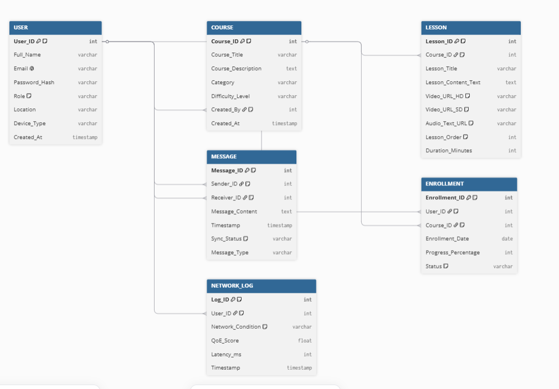

8.Backend Implementation
This part of the document explains the backend (server-side) of the Adaptis adaptive eLearning platform. The backend handles everything that happens behind the scenes — storing data, checking who's logged in, and responding to requests from the mobile app.

In simple terms, the backend is the engine of the app. When a student logs in, completes a lesson, or sends a message — the backend processes that action, saves the result, and sends back a response.

What Does It Do?
- Lets users register and log in securely
- Manages courses, modules, and lessons
- Tracks each student's learning progress
- Handles messaging between teachers and students
- Sends notifications to users
- Controls who can access what based on their role (student, teacher, or admin)
- Includes a demo mode that fills the database with sample data for presentations

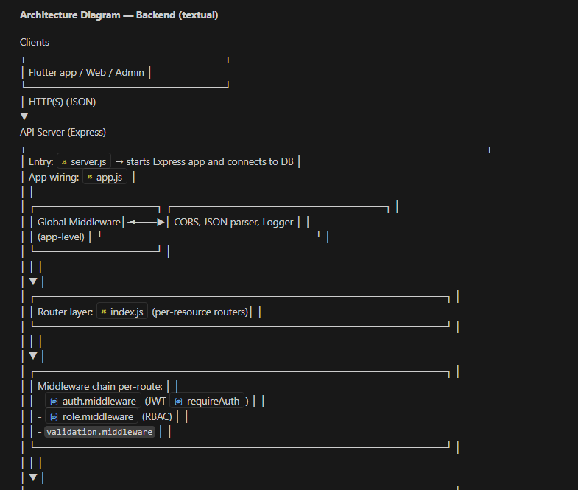

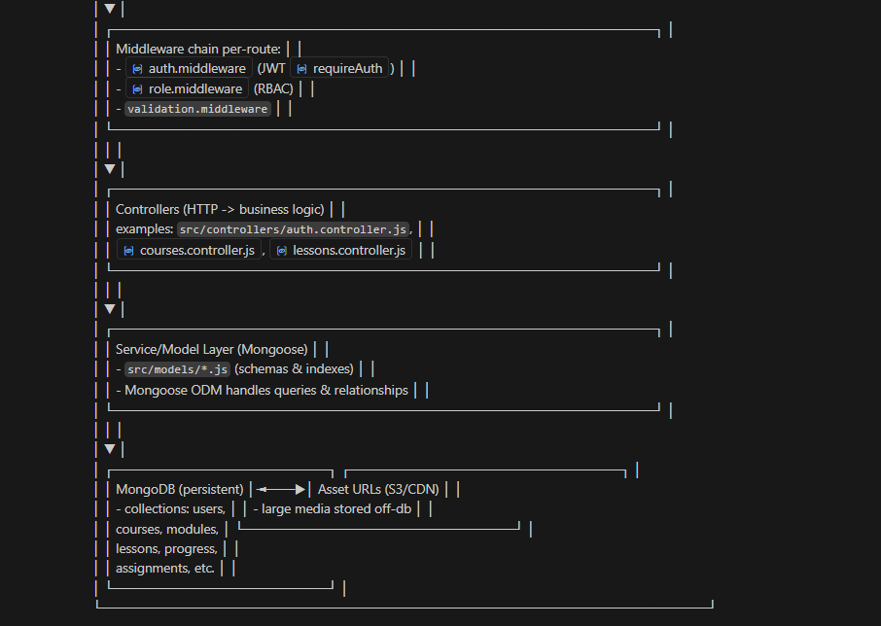

2. Technologies Used
Below is a breakdown of the main tools and libraries that power this backend, and what each one does.

Technology | What it does
Node.js | The runtime environment — it lets us run JavaScript on the server, not just in the browser.
Express | A web framework that makes it easy to define API routes and handle incoming requests.
MongoDB | The database where all data is stored — users, courses, lessons, messages, and more.
Mongoose | A tool that helps us define and work with MongoDB data using structured schemas.
JWT | Short for JSON Web Token — used to keep users logged in securely without storing sessions.
bcrypt | Securely scrambles (hashes) passwords before saving them, so they can't be read if leaked.
dotenv | Loads private settings (like database passwords) from a hidden config file.
CORS | Allows the mobile app to communicate with the backend even from a different domain.
nodemon | A development tool that automatically restarts the server when code changes are saved.

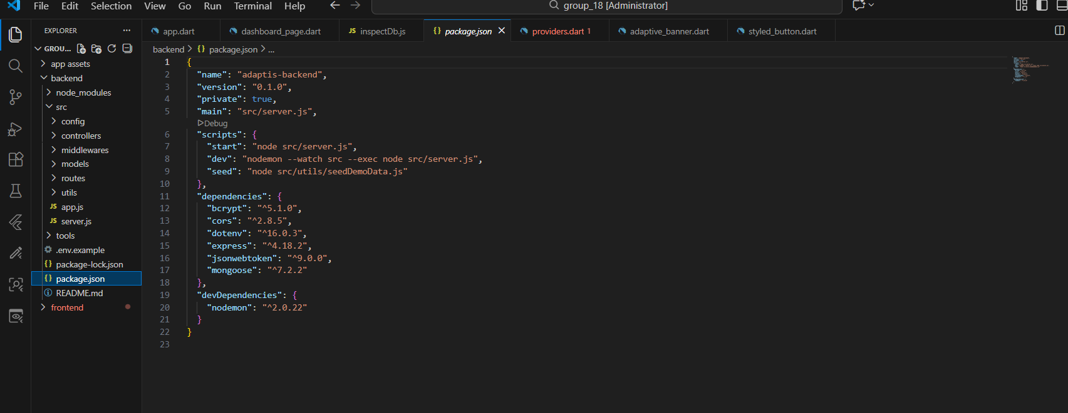

3. Project Structure
The project is organized into clear folders so that each part of the code has a specific job. Here is a summary of the key files and what they do.

server.js | The starting point — connects to the database and starts the server.
app.js | Sets up the Express app, loads middleware, and connects all the routes.
routes/index.js | The central file that links all route groups together.
controllers/ | Contains the business logic — what happens when each API endpoint is called.
models/ | Defines the structure of data stored in MongoDB (users, courses, lessons, etc.).
middlewares/ | Reusable functions that run before or after requests (e.g., checking login tokens).
seedDemoData.js | Fills the database with sample data for demos and presentations.
logger.js | A helper that logs activity to the console for debugging and monitoring.

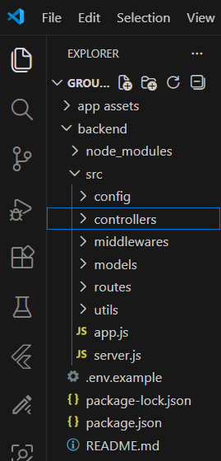

4. Data Models
A data model is the blueprint for how information is stored in the database. Below is a plain-language summary of the key models used in this project.

User
Stores everyone who has an account on the platform.
- Name, email address, and hashed password
- Role: student, teacher, or admin
- Extra profile info stored in a 'meta' field
- Passwords are never stored as plain text — always scrambled with bcrypt

Course
Represents a full course available on the platform.
- Title, description, category, and tags
- Linked to a teacher (by their user ID)
- Contains a list of modules
- Searchable by title and description

Module
A section within a course, containing multiple lessons.
- Linked to a course
- Has a title and display order
- Contains a list of lessons

Lesson
A single learning unit inside a module.
- Linked to both its module and course
- Contains a title, description, and order
- Supports video, audio, and text content
- Can be marked as downloadable for offline use

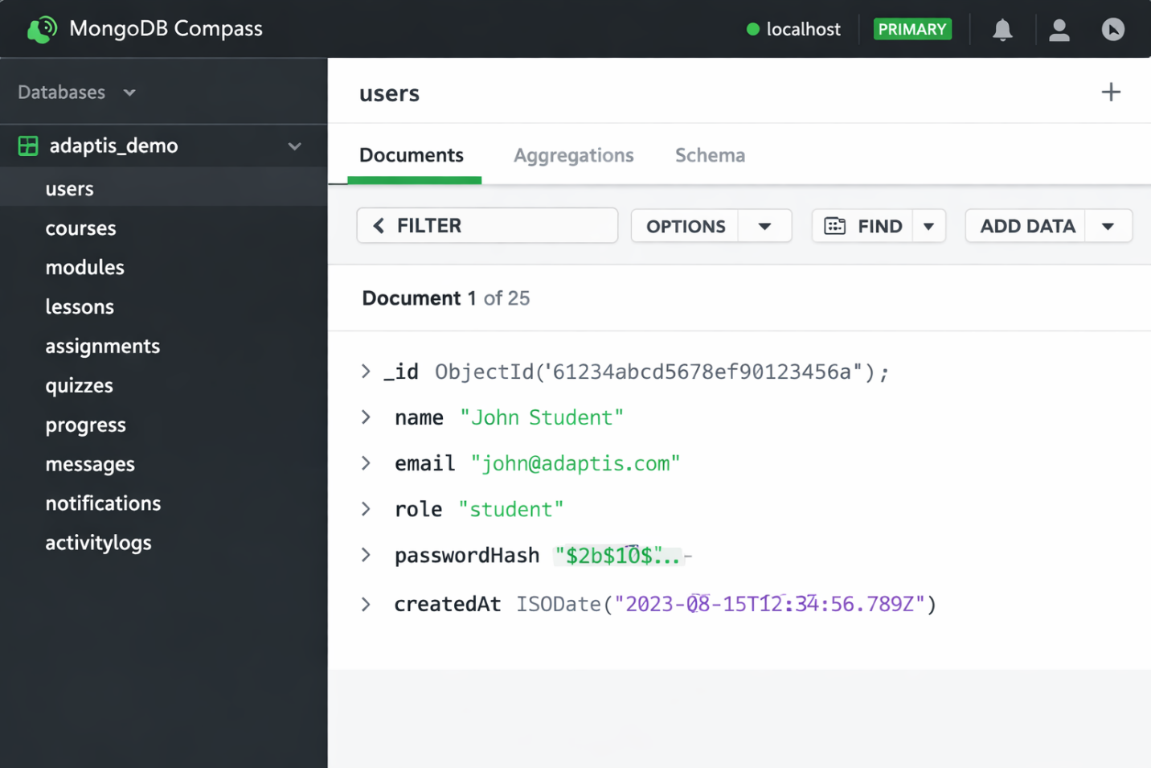

Other Models
Assignment / Submission | Stores assignment details and student responses, including grades.
Quiz / Question | Quiz metadata and question bank with multiple choice or open-ended options.
Progress | Tracks how far each student has gotten in each lesson (position + completion status).
Message | Stores messages exchanged between teachers and students.
Notification | Stores alerts sent to users about activity in the platform.
ActivityLog | Records actions taken by users for audit and monitoring purposes.

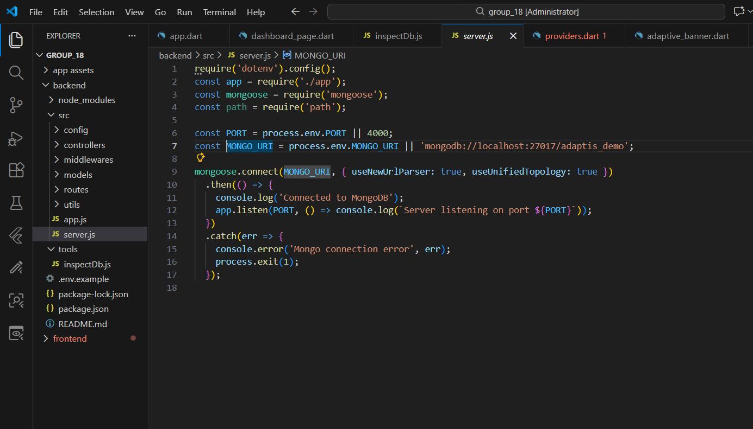
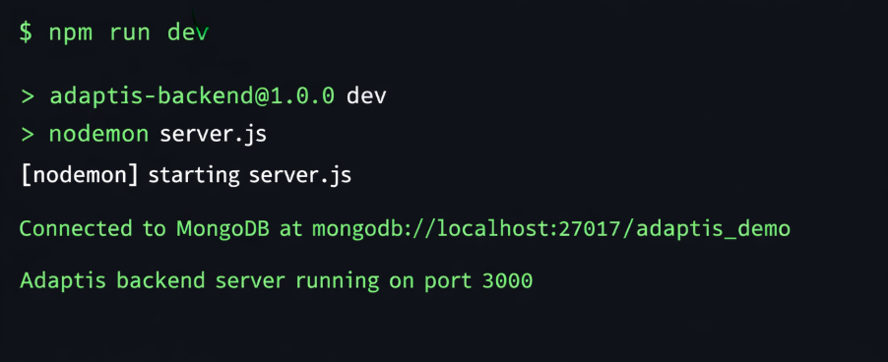

5. API Endpoints
An API endpoint is a URL that the mobile app calls to get or send data. Here is a summary of the main endpoints available in this backend.

Authentication (Public — No Login Required)
Endpoint | Method | Access
GET / | — | Public — health check
POST /api/auth/register | POST | Public — create a new account
POST /api/auth/login | POST | Public — log in and receive a token

Courses
Endpoint | Method | Access
GET /api/courses | GET | Public — list all courses
GET /api/courses/:id | GET | Public — view one course
POST /api/courses | POST | Teacher or Admin only
PUT /api/courses/:id | PUT | Teacher or Admin only
DELETE /api/courses/:id | DELETE | Teacher or Admin only

Lessons
Endpoint | Method | Access
GET /api/lessons | GET | Public — list lessons (filter by course or module)
GET /api/lessons/:id | GET | Public — view one lesson with assets
POST /api/lessons | POST | Teacher or Admin only
PUT /api/lessons/:id | PUT | Teacher or Admin only
DELETE /api/lessons/:id | DELETE | Teacher or Admin only

Progress, Assignments, Quizzes, Messages & Notifications
These all follow the same pattern — standard REST endpoints under /api/progress, /api/assignments, /api/quizzes, /api/messages, and /api/notifications. Access is controlled by role (student, teacher, or admin) depending on the action.
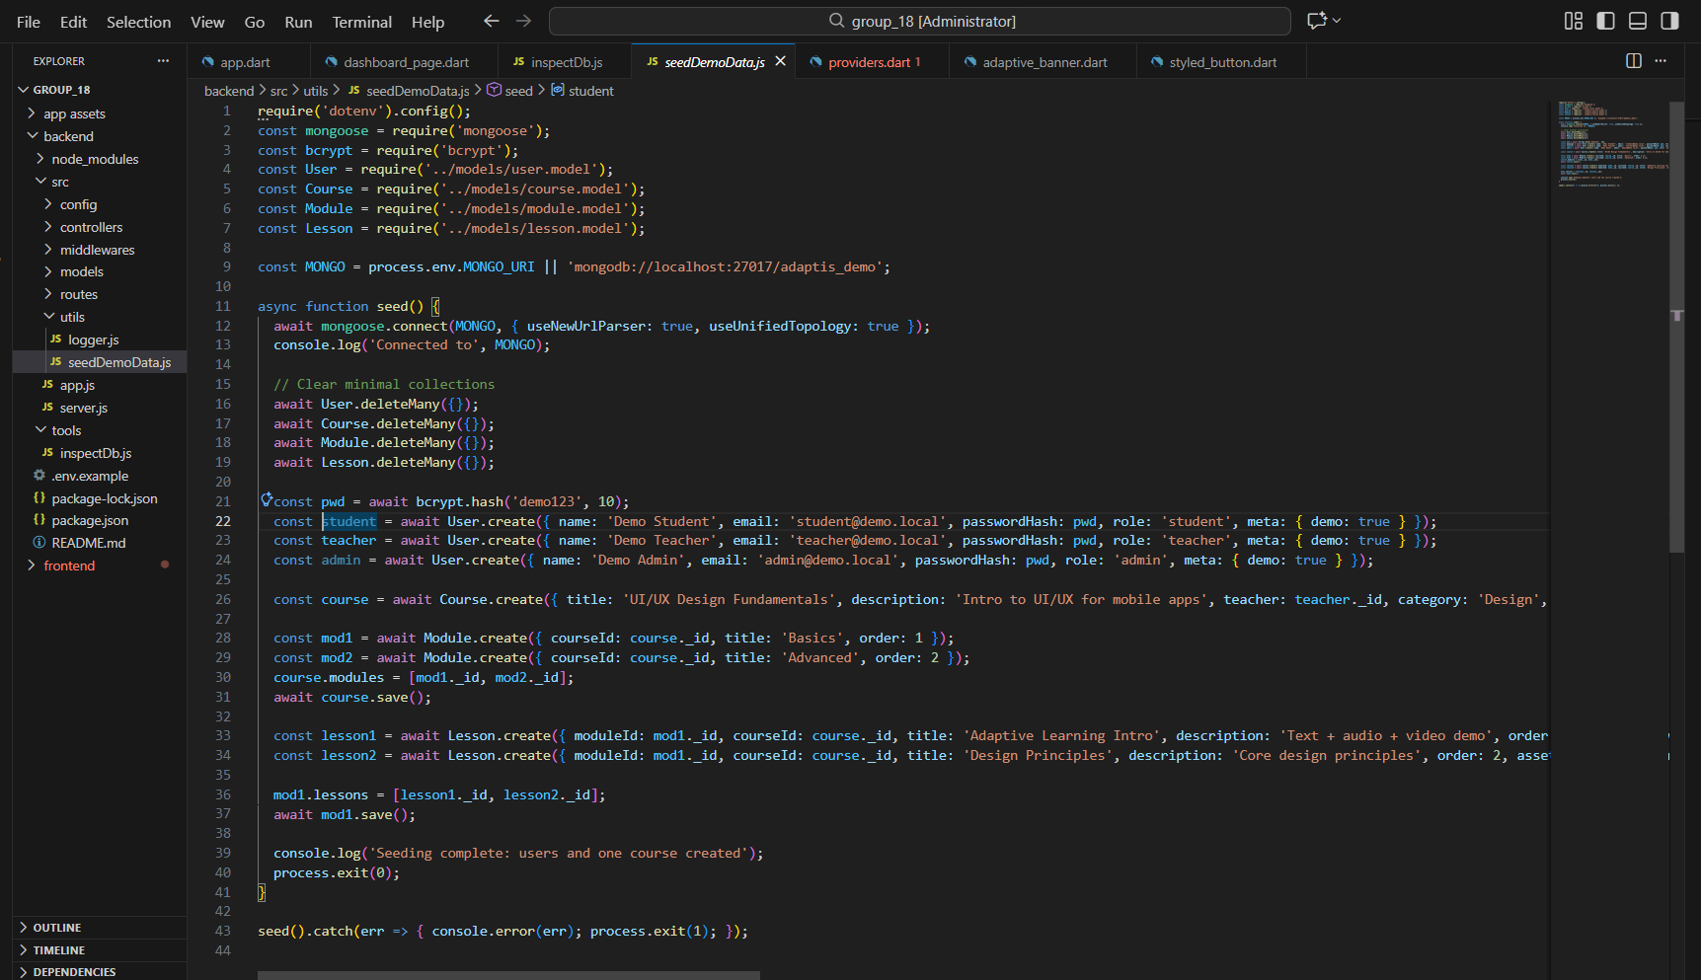
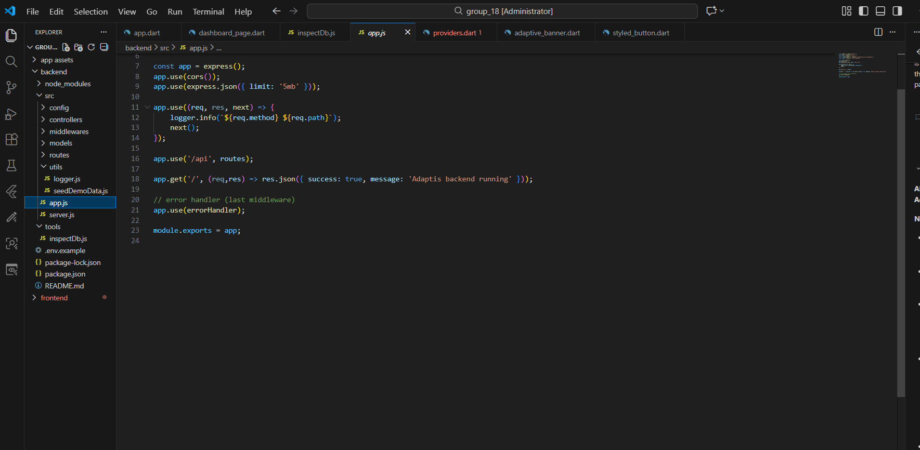
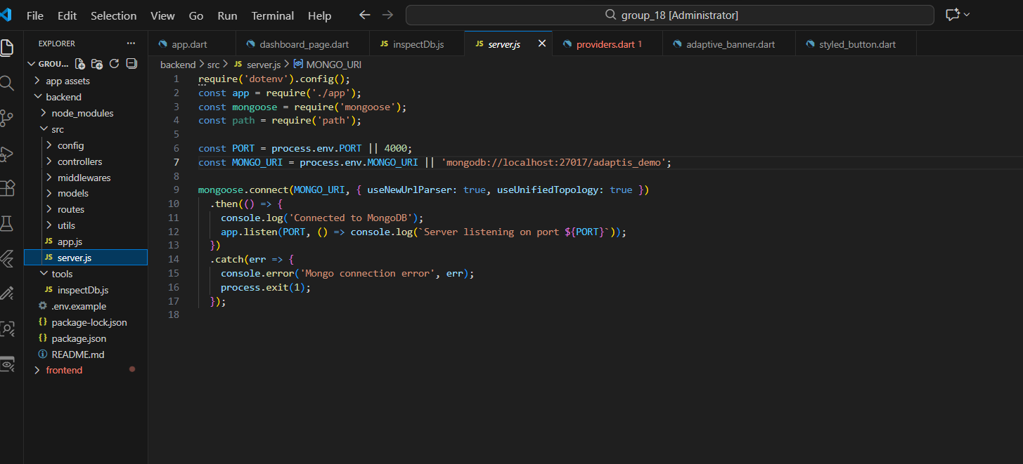
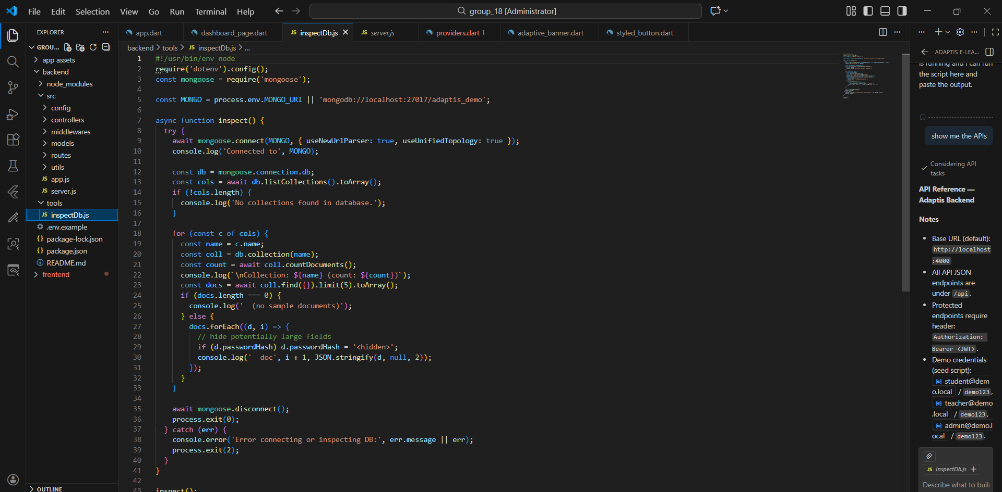

6. Login & Security
Security is handled through a combination of password hashing and authentication tokens. Here's how it works in plain steps.

How Login Works
- The user enters their email and password in the mobile app.
- The app sends those details to POST /api/auth/login.
- The backend checks if the email exists and if the password matches the stored hash.
- If everything is correct, the backend returns a JWT token.
- The app stores this token and sends it with every future request in the request header.
- The backend checks the token to confirm the user is logged in before processing the request.

Role-Based Access
Not everyone can do everything. The backend uses roles to control access:
student | Can view courses, complete lessons, submit assignments, and message teachers.
teacher | Can create and manage courses, lessons, assignments, and quizzes.
admin | Has full access to all resources and user management.

Password Security
Passwords are never stored as plain text. When a user registers, bcrypt scrambles the password into a hash. During login, bcrypt compares the entered password with the stored hash — the original password is never exposed.

7. Middleware & Utilities
Middleware are functions that run automatically before or after a request is handled. Here's what each one does.

auth.middleware.js | Reads the JWT token from the request header and confirms the user is logged in.
role.middleware.js | Checks if the logged-in user has the right role to perform the action.
error.middleware.js | Catches any errors that happen during a request and returns a clean error message.
validation.middleware.js | Checks that all required fields are present before processing a request.
CORS | Allows the mobile app (on a different address) to communicate with the backend.
logger.js | Logs every incoming request (method + path) to the console for monitoring.

8. Demo Mode
The backend includes a demo seeder that fills the database with realistic sample data. This is useful for presentations and testing without needing real users.

To run the demo seeder, use the following command in the terminal:
npm run seed

This will create sample users (student, teacher, and admin), a demo course with modules and lessons, and example progress, messages, and notifications.
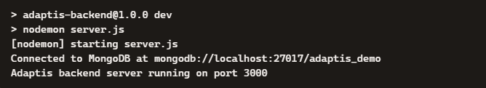

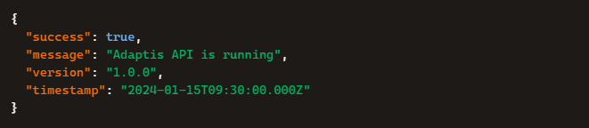

8.7 Conclusion

In conclusion, the database design and backend architecture of Adaptis establish a secure, performant framework tailored for unstable network environments. Transforming traditional relational data into an optimized document structure eliminates expensive runtime query operations and simplifies data retrieval. By consolidating multi-tier fallback formats into a single document collection, the Node.js and MongoDB backend empowers the mobile frontend to handle network drops natively. This setup ensures that students in low-resource settings can access learning materials uninterrupted, whether facing localized bandwidth drops or working entirely offline.

